**Report on the program 4 of Assignment 1  
Computer Vision (CS-559)**

**Name: Dhaval Harish Sharma  
Red ID: 824654344**

**Introduction:**This program takes an image as input and produces an output image which is enlarged using bilinear interpolation.

**Working of the program:**The program starts with importing the necessary libraries for its working. Skimage is used for converting the image to a numpy array as well as displaying the numpy array in the form of an image in the output. Initially, the image is taken as input and converted to a numpy array containing the corresponding pixel values in the image. After that the width and height of the image is calculated as well as the value of ‘k’ is taken from the user. Then, an output array is initialized in order to store the results of the reflection operation. We traverse the input image from left to right and top to bottom. We map the pixels from input image to a matrix of size k X k in the output image. The first element of this matrix becomes the pixel itself. Then, the first row of the matrix is calculated on the basis of bilinear interpolation of the pixel and its neighbour in the input image. After this, the last row is calculated on the basis of bilinear interpolation of the pixel and its immediate bottom neighbour. Then, the intermediate rows are calculated by bilinear interpolation of the first row and the last row. This process is continued for all the pixels of the input image. Finally, the output array is shown in the form of image in the output.

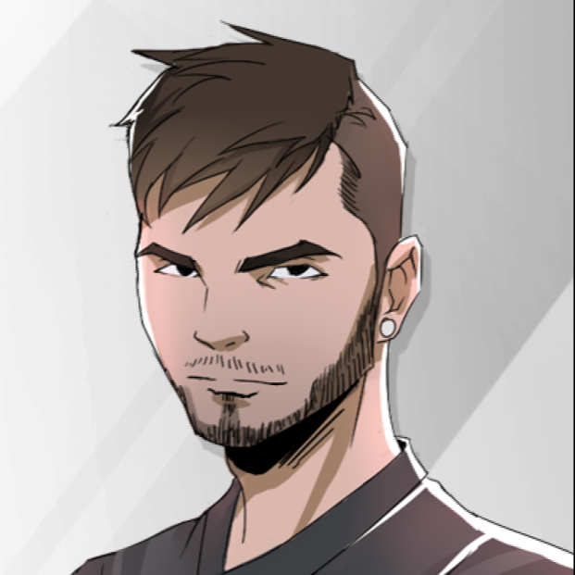

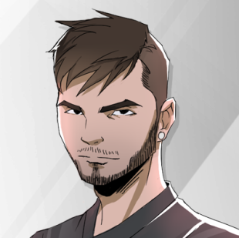

**Original Image**

**Enlarged Image (K = 2)**

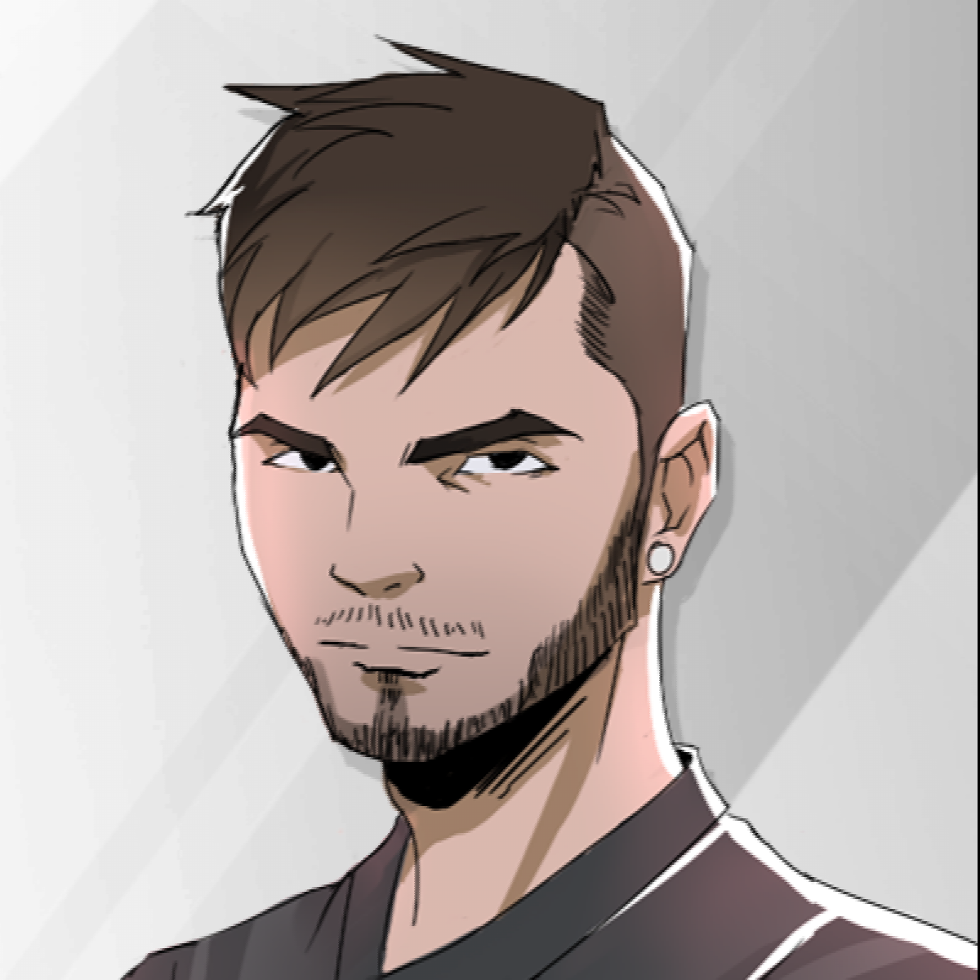

**Enlarged Image (K = 3)**

**Findings:**The images are just values in a matrix. In order to manipulate images, it is necessary to have a basic knowledge about various matrix operations. The image enlargement is a complicated procedure which consists of filling the empty pixels in the enlarged image. There can be various problems in this process because we need to fill the average values of the neighbouring pixels. It can be used to enlarge the image without losing much quality as compared to the procedure of copying the pixels from input image to output image. Also, it produces an output image with much smoother edges as compared to that of copying pixels.

**Conclusion:**Although the image enlargement is a difficult operation performed on an image, it can be very useful in the areas such as medical, security, space applications, etc.